Good afternoon

We are pleased to offer you our container storage services.

Our stock is located near the Kolyadichi station

Address: Kolyadichi Babyshkina st 17/5, 54, 82.

Maximum capacity 1600 containers

Three points of container unloading, to speed up the processing of containers.

Possibility to work on weekends (by agreement)

work schedule from 9-18.00 Mon-Fri

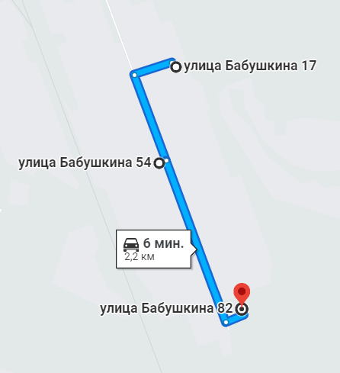

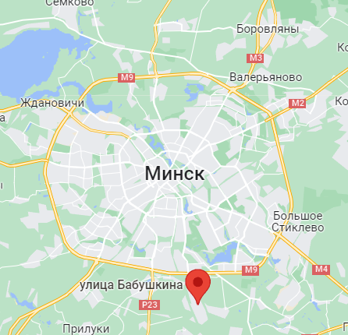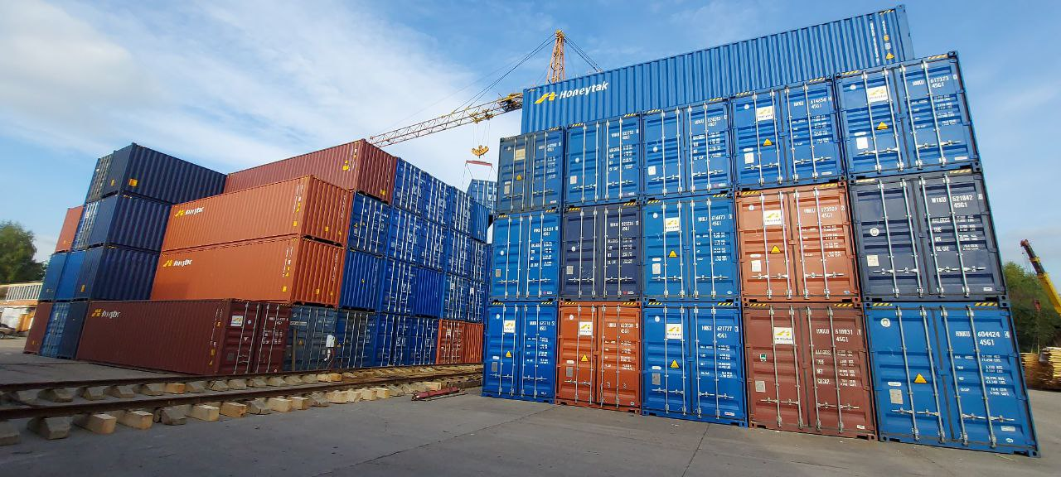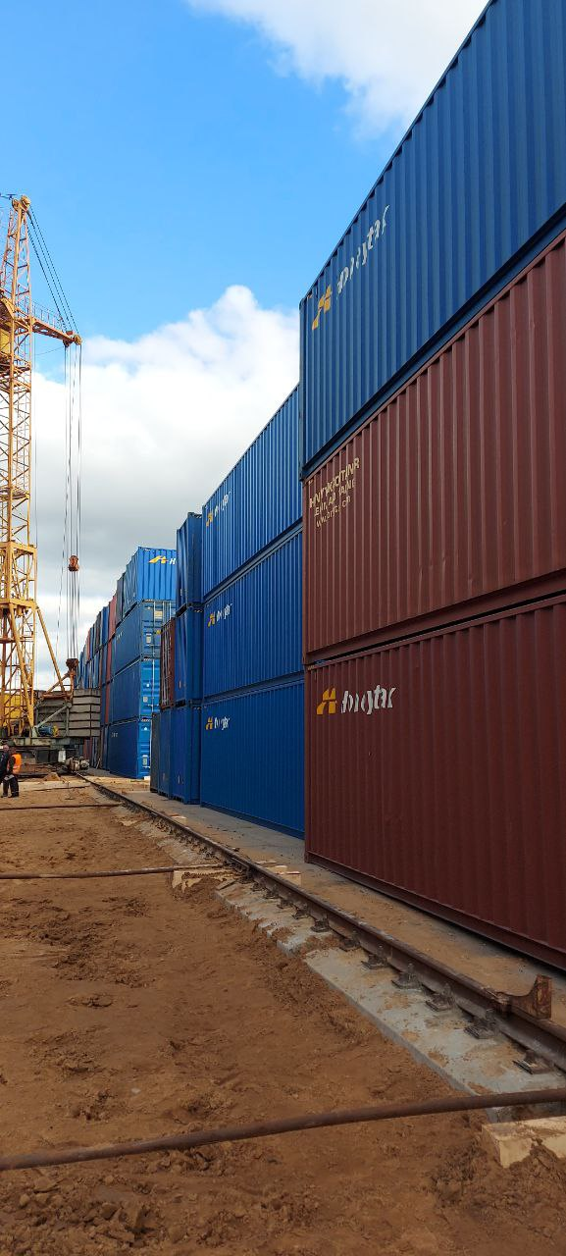

Release 15.06.2021 Contract №

The company ____________________ asks to accept for storage containers following from China to st. Kolyadichi. And provide storage services

|  |  |
| --- | --- |
| Description | Empty Containers |
| Container Type | 40HQ/20GP |
| Weight | < 5000 kg |
| Rates | 2 Crane operations – $60  Storage of an empty container - 3.75 $ / day  Container acceptance and document flow - $5  Repair of the container - as agreed. |
| Storage period | 1-365 дней |
| Validity of the rate | До 31.05.2023 |
| Add. Conditions | Container must be in good condition and cleaned |
| Container numbers |  |